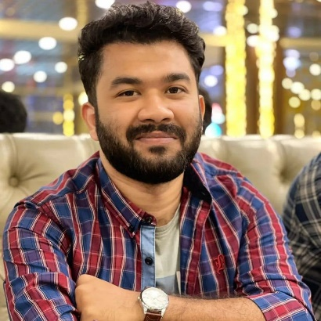

 github.com/Ankon78
 kuril chow-Rasta, Dhaka.
 linkedin.com/in/ankon-sarker84
 ankonsarker17@gmail.com
 01767553784
Ankon Sarker

I want to apply what I've learned as a fresher to launch a successful career. I enjoy a challenge and always try to do my best. Which I've demonstrated in my efforts. I want the opportunity to prove myself.
CONTACT
EDUCATION

Bachelor of Science : BSc in Computer Science and Engineering.
Institution : American International University-Bangladesh.
Leadership, Communication Skills
■ ■ ■ ■ ■ (Good)

SOFTWARE TESTING
■ ■ ■ ■ ■ (Average)

ASP .NET MVC
■ ■ ■ ■ ■ (Very Good)

C, C++, C#, JAVA
■ ■ ■ ■ ■ (Good)

HTML, CSS, PHP, MySQL
■ ■ ■ ■ ■ (Good)

MS-Word, MS-Excel, MS-PowerPoint
■ ■ ■ ■ ■ (Very Good)

SKILLS
Result : CGPA 3.54 out of 4.00
Passing Year : 2023
Higher Secondary Certificate (HSC)
Group : Science
Institution : Cantonment Public School and Collage,Rangpur.
Board : Dinajpur Education Board
Result : CGPA 5.00 out of 5.00
Passing Year : 2018

REFERENCE

